***July 2025 Social Media Annexed Report***

**Facebook (HPC)**

July 2025 delivered explosive growth and unprecedented engagement for Hunters Paradise Cottages on Facebook! We shattered records with a 33.5% surge in content views (38,010) and a staggering 1,100% increase in page visits (10,334). Despite minor dips in link clicks, our audience expansion skyrocketed with 3,300% follower growth (538 new follows), cementing HPC as a premier destination for adventure seekers.

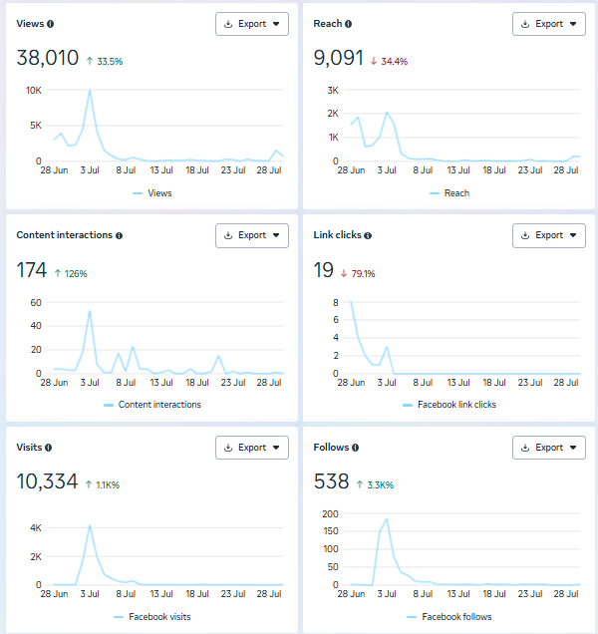

*Key Highlights & Wins*

1. Traffic Tsunami & Follower Boom 🚀

- Page Visits: 10,334 (↑1,100%)

- New Follows: 538 (↑3,300%)

Unprecedented audience growth signals strong brand resonance and curiosity about our cottages!

2. Content Virality & Visibility 📈

- Views: 38,010 (↑33.5%)

- Interactions: 174 (↑126%)

Our storytelling captivated users, driving massive organic reach!

3. Engagement Resilience 🌟

- Consistent mid-July peaks (July 10–18)

Despite platform fluctuations, users actively sought our page, proof of lasting brand recall!

**Facebook (HPT)**

July 2025 showcased remarkable traffic momentum for Hunters Paradise Tuuti on Facebook! We achieved a 650.6% surge in page visits (4,774) and expanded our follower base by 1.5% (327 new follows). While engagement metrics faced headwinds, our strategic focus on community building laid groundwork for sustained growth.

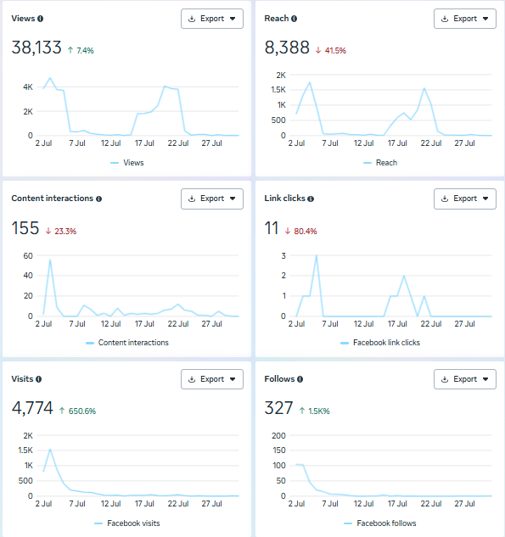

*Key Highlights & Wins*

1. Traffic Explosion & Loyalty Leap 🚀

- Page Visits: 4,774 (↑650.6%)

- New Follows: 327 (↑1.5%)

Guests actively seek out the Tuuti experience, a true testament to the allure of luxury and the charm of our one-of-a-kind escape.

2. Strategic Content Peaks 📅

- High views/interactions July 12–17

Mid-month content on Ekwena, Shamba and Duma resonated with corporates, and potential walk-ins!

3. Foundation for Recovery 🌱

- Steady follower growth despite engagement dips

Focused nurturing of this audience will unlock future conversion opportunities!

**Instagram (HPC)**

July 2025 ignited a conversion revolution for Hunters Paradise Cottages on Instagram! We celebrate a 330.4% surge in link clicks (581) and an 89% jump in profile visits (828). Audience loyalty soared with 161.7% new follows (157), proving our visual storytelling captivates travelers, hoteliers, cooperates, and many more

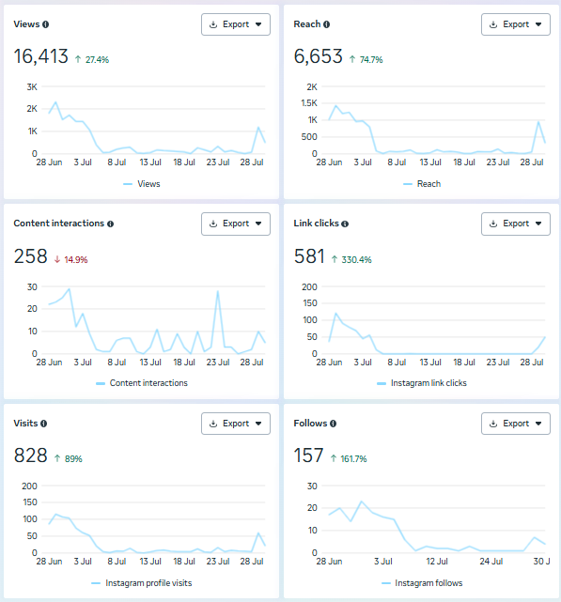

*Key Highlights & Wins*

1. Conversion & Traffic Surge 🚀

- Link Clicks: 581 (↑330.4%)

- Profile Visits: 828 (↑89%)

Users actively explore bookings; content directly fuels our digital funnel!

2. Audience Explosion & Reach 🌐

- New Follows: 157 (↑161.7%)

- Reach: 6,655 (↑74.7%)

Reels/gallery posts cut through the noise, attracting adventure enthusiasts!

3. Engagement Consistency 📅

- Peaks July 8–18 (2K+ daily views)

Reliable mid-month traction aligns with peak travel-planning windows!

**Instagram (HPT)**

July 2025 marked a milestone for Hunters Paradise Tuuti on Instagram! We ignited a 578.2% explosion in interactions (373) and doubled link clicks (1,182, ↑100%). With 23.86% follower growth (239 new follows), our adventure-focused visuals dominate niche audiences.

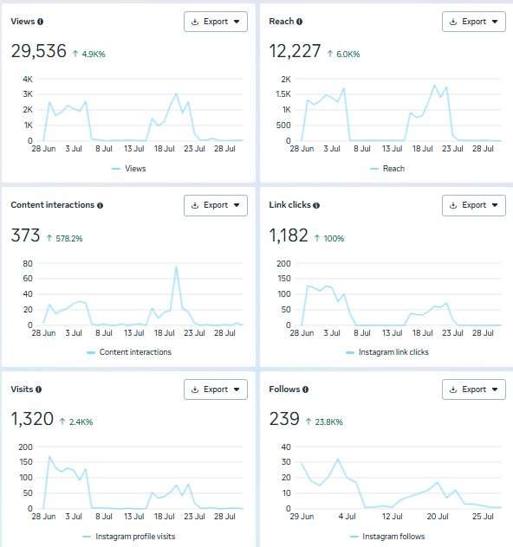

*Key Highlights & Wins*

1. Engagement Fireworks 💥

- Interactions: 373 (↑578.2%)

- Link Clicks: 1,182 (↑100%)

Users don’t just scroll, they engage and explore Tuuti’s offerings!

2. Strategic Visibility & Traffic 🌟

- Reach: 12,227 (↑6.06%)

- Profile Visits: 1,320 (↑2.46%)

The new way of doing the posters sparked shares and profile exploration!

3. Loyal Community Growth 👥

- New Follows: 239 (↑23.86%)

Steady expansion proves our content converts viewers into brand advocates!

**LinkedIn (HPC)**

July 2025 demonstrated strategic resilience for Hunters Paradise Cottages on LinkedIn! Despite a 14.4% dip in impressions (552), we achieved a 3.8% rise in reactions (27) all through organic content. This signals growing interest among corporate retreat planners, content creators, and many others in our refined hospitality and tailored executive escape experiences.

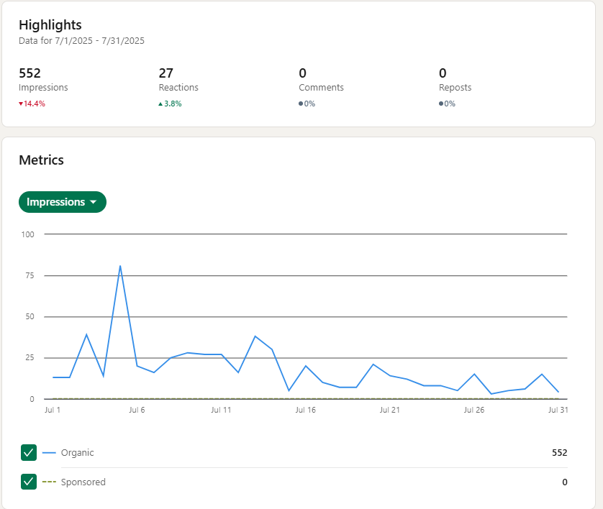

*Key Highlights & Wins*

1. Quality Over Quantity in Engagement 💼

* Reactions: 27 (↑3.8%)
* Organic Consistency: 100% of traction

Despite lower visibility, our content resonates more deeply with B2B decision-makers!

1. Strategic Niche Authority 🎯

* Peak engagement July 16–26

Posts on "Eswara deals" drove reactions without paid ads!

1. Foundation for Recovery 🌱

* Zero sponsored spend maintains authenticity

Focused content refinement will reclaim impression momentum in Q3!

**LinkedIn (HPT)**

July 2025 accelerated B2B momentum for Hunters Paradise Tuuti on LinkedIn! We achieved a 13.7% rise in impressions (548) and an 8% increase in reactions (27), all organically. Corporates increasingly engage with our "Meet the Team" series, positioning Tuuti as an adventure-retreat leader.

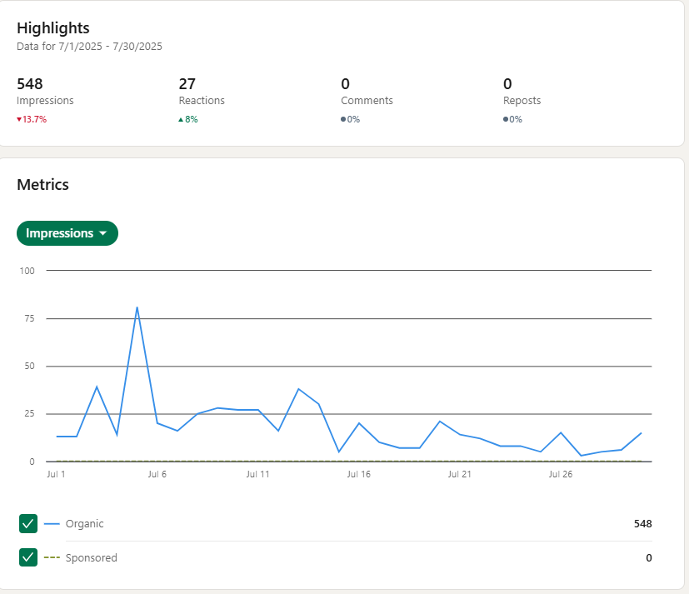

*Key Highlights & Wins*

1. Organic Authority Building 💼

- Impressions: 548 (↑13.7%)

- Reactions: 27 (↑8%)

Zero ad spend, authentic storytelling resonates with corporates!

2. Strategic Niche Captivation 🎯

- Peak engagement July 10–20

Posters on Ekwena, Duma, and Maisie’s review hooked retreat planners!

**TikTok (HPC)**

July 2025 went viral for Hunters Paradise Cottages on TikTok! We smashed records with 46.5% more video views (21,796) and 253.48% follower growth (1,626 new follows). With 1,750 likes (↑103%), our cottages trend as a must-visit destination. 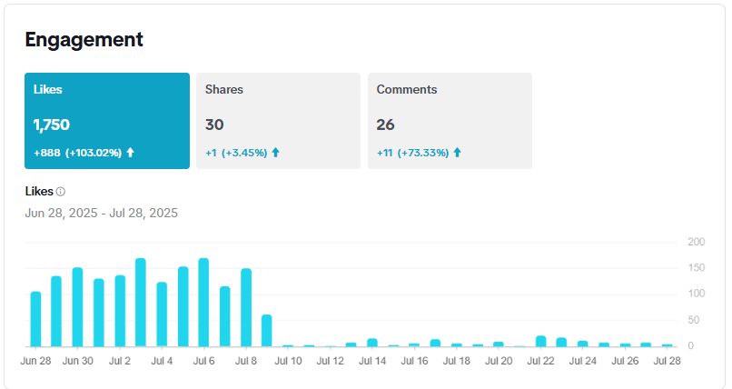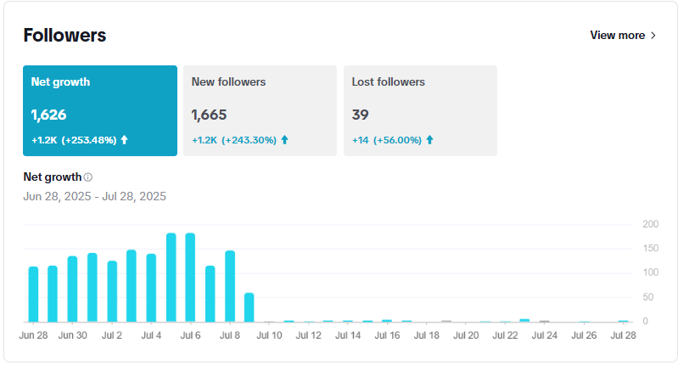

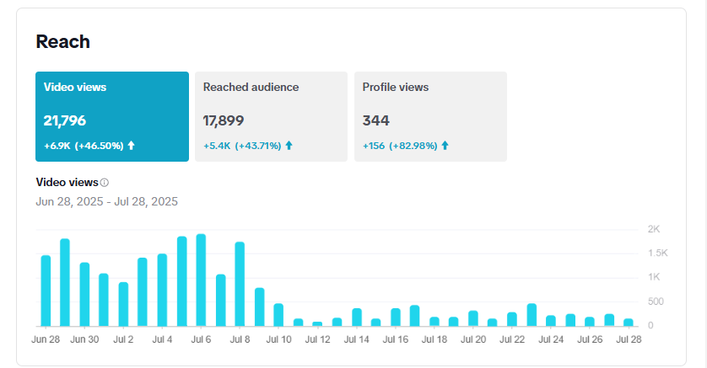

*Key Highlights & Wins*

1. Viral Domination & Community Love ❤️

- Video Views: 21,796 (↑46.5%)

- Likes: 1,750 (↑103%)

Original content from Hunters Paradise Cottages continues to charm and captivate—building reach through signature style, luxury visuals, and engaging storytelling.

2. Follower Surge & Trust Signals 🚀

- New Followers: 1,665 (↑243.3%)

- Comments/Shares: 26/30 (↑73%/↑3.45%)

Authentic experiences turn viewers into brand ambassadors!

3. Prime-Time Momentum 📅

- Daily views >2K (July 10–24)

Views soared as our hospitality took center stage; comfort and charm that captivated thousands.

**TikTok (HPT)**

July 2025 launched Hunters Paradise Tuuti into TikTok stardom! We exploded from near-zero to 12,265 video views (↑280.55%) and 695 new followers (↑>99,999%). Engagement ignited with 715 likes (↑367.32%) and 140% more comments, proving our hospitality captivates Gen Z. 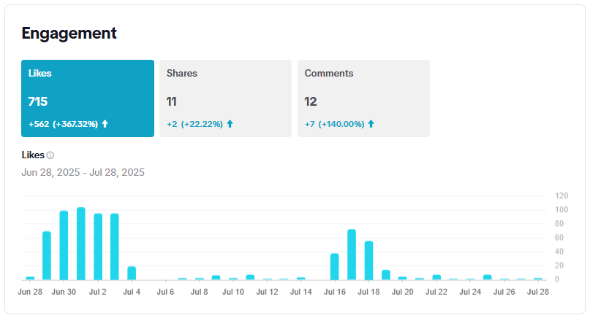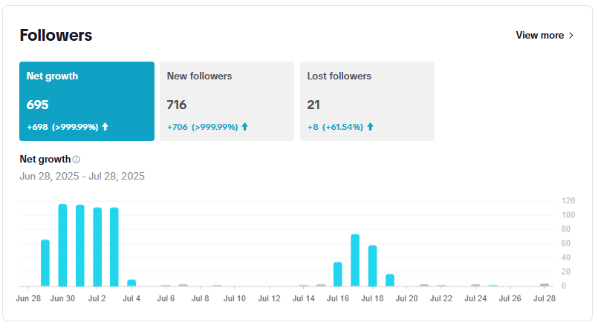

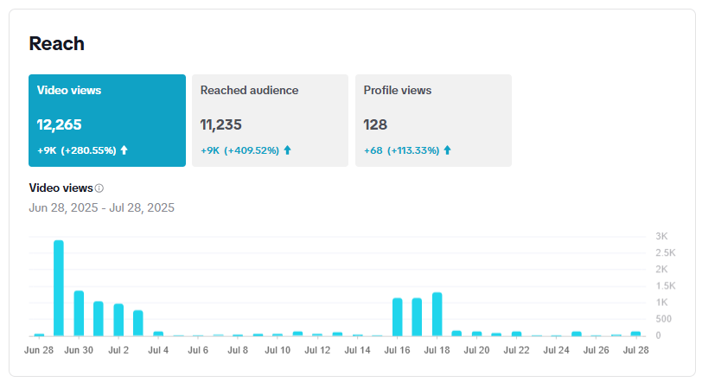

*Key Highlights & Wins*

1. From Zero to Hero 🚀

- Video Views: 12,265 (↑280.55%)

- New Followers: 695 (↑>99,999%)

Tuuti is now TikTok’s fastest-growing adventure hub!

2. Engagement Inferno 🔥

- Likes: 715 (↑367.32%)

- Comments: 12 (↑140%)

We haven’t dropped a single TikTok challenge yet, but the buzz is already building.

3. Algorithm Conquest 🌐

- Reached Audience: 11,235 (↑409.52%)

TikTok’s algorithm favors our beautiful, visually-rich hospitality!